ASSIGNMENT 4

Write Code and connections in WOKWI for ultrasonic sensor. Whatever distance is less than 100 cm send “Alert” to IBM cloud and display in device recent events.

Solution:

//Pins
const int TRIG_PIN = 7 ;
const int ECHO_PIN = 8;
//Anything over 400 cm (23200 us pulse) is "out of range"
const unsigned int MAX_DIST = 23200;
void setup() {
// The Trigger pin will tell the sensor to range find
Pin Mode(TRIG_PIN, OUTPUT);
digital Write(TRIG_PIN, LOW);
//Set Echo pin as input to measure the duration of
//pulses coming back from the distance sensor
pinMode(ECHO_PIN, INPUT ) ;
// We'll use the serial monitor to view the sensor output
Serial.begin(9600);
}
void loop() {
unsigned long t1;
unsigned long t2;
unsigned long pulse_width;
float cm;
float inches;
// Hold the trigger pin high for at least 10 us
digitalWrite(TRIG_PIN, HIGH);
delayMicroseconds(10);
digitalWrite(TRIG_PIN, LOW);
// Wait for pulse on echo pin
while (digitalRead( ECHO_PIN )==0 );
// Measure how long the echo pin was held high (pulse width)
// Note: the micros() counter will overflow after-70 min
t1= micros ();
while (digitalRead(ECHO_PIN) == 1);
t2= micros ();
pulse_width = t2-t1;
// Calculate distance in centimeters and inches. The constants
//are found in the datasheet, and calculated from the assumed speed
// of sound in air at sea level (- 340m/s)
cm=pulse_Width / 58 ;
inches = pulse_width/148.0;
unsigned long t2;
unsigned long pulse_width;
float cm;
float inches;
// Hold the trigger pin high for at least 10 us
digitalWrite(TRIG_PIN, HIGH);
delayMicroseconds(10);
digitalWrite(TRIG_PIN, LOW);
// Wait for pulse on echo pin
while (digitalRead( ECHO_PIN )==0 );
// Measure how long the echo pin was held high (pulse width)
// Note: the micros() counter will overflow after-70 min
t1= micros ();
while (digitalRead(ECHO_PIN) == 1);
t2= micros ();
pulse_width = t2-t1;
// Calculate distance in centimeters and inches. The constants
//are found in the datasheet, and calculated from the assumed speed
// of sound in air at sea level (- 340m/s)
cm=pulse_Width / 58 ;
inches = pulse_width/148.0;
Output:

1.If the distance is less than 100 cm , it alerts.
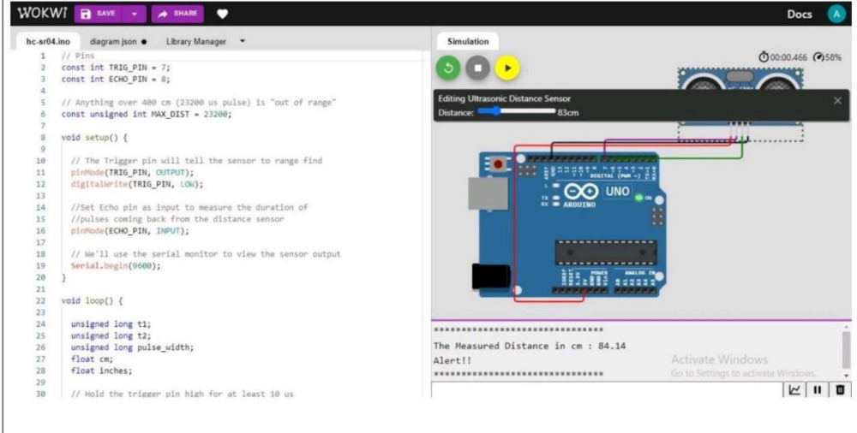

2. If the distance is more than 100 cm, it won’t alert
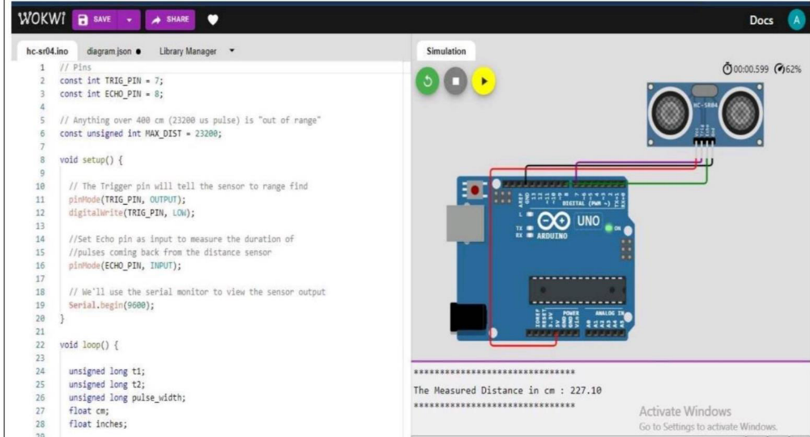

3. Simulation and code execution
